Revision Planning 2022
How to create a Revision Timetable…and STICK to it!

Name:

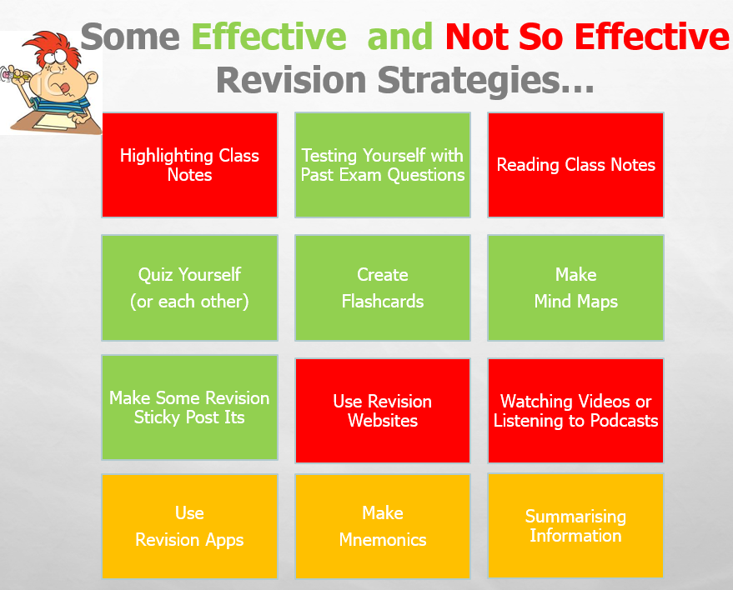
You must do something with the information, otherwise your time is wasted!
English | Maths | Geography | History | Computing
Component 1 Language Fiction Reading Section A | Mathswatch Assignments – complete fortnightly assignments | The changing landscapes of the UK | USA – 1920s People and the Boom | Systems architecture (Comp 1)
Component 2 Language Non-fiction Reading section A |  | River landscapes and processes | USA– 1930s Depression and the New Deal | Memory and storage (Comp 1)
Comp 1 Sect B - Creative prose writing - story | Past Paper booklets – work through them | Glaciated upland landscapes and processes | USA– Post-war America | Computer networks, connections and  protocols (Comp 1)
Comp 2 Sect B Transactional writing –, articles, formal letters |  | Weather hazards and climate change | Conflict and Tension – Treaty of Versailles | Network security (Comp 1)
 | Hegarty Maths – complete outstanding tasks, Memri or Fix Up 5 | Ecosystems, biodiversity and management | Conflict and Tension – League of Nations | Systems software (Comp 1)
 |  | Changing cities | Conflict and Tension – Causes of WWII | Ethical, legal, cultural and environmental  impacts of digital technology (Comp 1)
 | Revision workbooks – work through them | Resource management | Elizabethan England – Elizabeth & government | Algorithms (Comp 2)
 | Mock AFL – follow up on weakest topics | Energy resource management | Elizabethan England – Life in Elizabethan times | Programming fundamentals (Comp 2)
 |  | Cities fieldwork – Theory | Elizabethan England – troubles home & abroad | Producing robust programs (Comp 2)
 | Flashcards – revise topics and use the QR code to access practice questions | Rivers fieldwork - Theory | Elizabethan England – the 16 mark question – Burghley’s Almshouses | Boolean logic (Comp 2)
 | Individual revision – tutoring, websites, exercise books, alternative resources | UK Challenge |  | Programming languages and Integrated  Development Environments (Comp 2)

Biology  SET YT & ZT | Chemistry  Set YT & ZT | Physics  Set YT & ZT | Combined Science | Combined Science  (Cont) | ART -  What should be in my sketch book
Cell biology | Atomic structure and the periodic table | Energy | B1 Cell biology | C7 Organic chemistry | Title page
Organisation | Bonding, structure, properties of matter | Electricity | B2 Organisation | C8 Chemical analysis | Mood board
Infection and response | Quantitative chemistry | Particle model of matter | B3 Infection and response | C9 Chemistry of the atmosphere | Mind maps
Bioenergetics | Chemical changes | Atomic structure | B4 Bioenergetics | C10 Using resources | Artist #1
Homeostasis & response | Energy changes | Forces | B5 Homeostasis & response | P1 Energy | Artist #2
Inheritance, variation and evolution | The rate and extent of chemical change | Waves | B6 Inheritance, variation and evolution | P2 Electricity | Artist #3
Ecology | Organic chemistry | Magnetism and electromagnetism | B7 Ecology | P3 Particle model of matter | Double page of lines drawings
 | Chemical analysis | Space (phys only) | C1 Atomic structure and periodic table | P4 Atomic structure | Double page of tonal studies
 | Chemistry of the atmosphere |  | C2 Bonding, structure, and properties of matter | P5 Forces | Double page of colour studies
 | Using resources |  | C3 Quantitative chemistry | P6 Waves | A still life group- full page
 |  |  | C4 Chemical changes | P7 Magnetism and electromagnetism | Compositions sketches
 |  |  | C5 Energy changes |  | Final design and colour notes
 |  |  | C6 The rate and extent of chemical change

PE |  | Drama | RE | Food Preparation and Nutrition
Applied Anatomy and physiology  Skeletal system  Muscular system  Cardiovascular system | Respiratory system  Aerobic and anaerobic exercise  Short- and long-term effects of exercise | Prepare and finish their performances for 2nd March for devised performance (worth 40% of the final grade) | Christian Beliefs  TRINITY, CREATION, INCARNATION AND PROBLEMS OF EVIL AND SUFFERING AND | Food commodities – starchy foods and animal protein foods.  Origins, value in the diet, storage and working characteristics
Movement Analysis  Lever systems | Planes and axes of rotation | Complete and submit 2,500 word devising log (which we are completing in school from 2nd February-end of March) | Living the Christian Life  SACRAMENTS, PRAYER, RELIGIOUS CELEBRATIONS AND THE CHURCH WORLDWIDE | Principles of Nutrition  Macro and micronutrients  For protein – essential amino acids, specific function, main sources, dietary reference values, consequences of malnutrition, complementary actions
Physical Training  Components of fitness  Fitness tests | Principles of training  Prevention of injury | Revise and learn their live theatre review focusing on two actors in two to three scenes, and one actor in three scenes. | Marriage and the Family (Christianity) – Full Unit | Food Science – why we cook food, heat transference, raising agents and use of microorganisms
Health, fitness and well-being  Physical, social and emotional health | Diet and nutrition  Hydration | Revise and learn all staging (in the round, promenade, end on etc), positions of stage and the roles and responsibilities in a theatre. | Matters of Life and Death (Christianity) – Full Unit | Diet and Good Health - energy requirements of individuals and balanced diets, including life stages, specific dietary needs and lifestyle factors.  Energy and nutritional needs – how to calculate, individual needs throughout life, how to change diets understand and apply the principle of energy balance
Sports psychology  Characteristics of skilful movement  Classification of skills | Goal setting  Mental preparation  Types of guidance  Types of feedback | Revise and secure how they would use their physical and vocal skills to play Linda, Mickey, Edward, Mrs Lyons, Mrs Johnstone and Sammy throughout the play (Blood Brothers) | Muslim Beliefs  THE 5 ROOTS, THE NATURE OF ALLAH, RISALAH AND AL-QADR | The Science of Food – the effect of cooking on food. Why food is cooked heat transfer, selecting appropriate cooking methods, why things go wrong and how to remedy  Food Spoilage – hoe to store, importance of date marks, growth conditions, signs of spoilage, cross-contamination
Socio-cultural influences  Physical activity and sport in the UK  Participation in physical activity and sport | Commercialisation of sport  Ethics in sport  Drugs in sport  Violence in sport | Revise and secure the language of set design | Living the Muslim Life  SHAHADAH, SALAH, SAWN AND CELEBRATIONS | Where food comes – provenance and manufacture, including food miles, carbon footprint, local foods. Primary and secondary processing
 |  | Revise and secure the language of costume design |  | Cooking and Food Preparation – factors that affect food choice and how to make informed food choices
 |  | Revise and secure the language of lighting | Crime and Punishment (Islam)
 |  | Revise and secure the language of puppets | Peace and Conflict (Islam)
 |  | Revise and secure the language of sound design.

French | German | Music
Theme 1 - Identity and culture:  Me, my family and friends | Theme 1 – Identity and culture:  Me, my family and friends / relationships with family & friends / marriage & partnership | Western Classical Tradition 1650-1910 –  Coronation Anthems and Oratorios  Orchestral music of Haydn, Mozart and Beethoven
Theme 1 - Identity and culture  Technology in everyday life  Food and drink (taken from free-time activities) | Theme 1 – Identity and culture:  Food & eating out  Technology in everyday life / social media / mobile technology | Western Classical Tradition 1650-1910 –  Piano music of Chopin and Schuman  The requiem of the late romantic period
Theme 1 - Identity and culture  Free time activities | Theme 1 – Identity and culture:  Free time activities (music / cinema / TV / sport) | Popular Music –  The music of Broadway 1950-1990  Rock music of the 1960 – 1970s
Theme 1 - Identity and culture  Customs and festivals | Theme 1 – Identity and culture:  customs & festivals  Theme 2 – Local, national, international & global areas of interest:  Transport | Popular Music –  Film and computer gaming music from 1990 to present day  Popular music from 1990 to present day
Theme 2 - Local, national, international and global areas of interest  Clothes (taken from Home, town, neighbourhood and region) | Theme 2 – Local, national, international & global areas of interest:  Travel & tourism, including weather & climate | Traditional Music –  Blues Music 1920-1950  Fusion music incorporating African and Caribbean
Theme 2 - Local, national, international and global areas of interest  Home, town, neighbourhood and region | Theme 2 – Local, national, international & global areas of interest:  Home, town, neighbourhood & region | Traditional Music –  Contemporary Latin Music  Contemporary folk music of the British Isles
Theme 2 - Local, national, international and global areas of interest  Travel & tourism | Theme 2 – Local, national, international & global areas of interest:  Global issues  Social issues | Western Classical since 1910 –  The orchestral music of Aaron Copland  British music of Arnold, Britten, Maxwell Davis and Tavener
Theme 2 - Local, national, international and global areas of interest  Social issues  Global issues  Weather (taken from General vocabulary) | Theme 3 – Current and future study and employment  My studies / life at school | Western Classical since 1910 -  The music of Zoltan Kodaly and Bela Bartok  Minimalist music of John Adams, Steve Reich and Terry Riley
Theme 3 - Current and future study and employment  My studies & life at school and college | Theme 3 – Current and future study and employment  Education post-16  Jobs, career choices & ambitions | Elements –  Dynamics, tonality, texture, sonority, melody, harmony, structure
Theme 3 - Current and future study and employment  Education post 16 / Jobs, career choices and ambitions | AVOCADOS structures for the writing examination | Mozart’s Clarinet Concerto
AVOCADOS structures for the writing examination |  | Little Shop of Horrors

Then you need to break subjects into smaller topics/units as per example started below:
What I need to revise: | Shakespeare | Blood Brothers | A Christmas Carol | Poetry Anthology | Unseen Poetry | Component 1 Reading | Component 2 Reading | Writing
 | 1. Characters - | 1. Mickey | 1.Context | 1. Themes and links | Sample poems | 1. The ‘How’ Question | 1. The ‘How’ Question | 1. Story
 | 2. | 2. Edward | 2.Scrooge | 2. Conflict  Mametz Wood | Past papers | 2. What impressions question | 2. What impressions question | 2. Speech
 | 3. | 3. Mrs Johnstone | 3. Ghosts | 3. Manhunt |  | 3. The mood and setting question | 3. Compare and contrast question | 3. Report
 | 4 | 4 Mrs Lyons | 4. The Cratchits, Tiny Tim, Bob | 4. Ozymandias |  | 4. How does the writer build tension question | 4. Thoughts and feelings question | 4. Review
 | 5 Themes | 5 Linda and Mr Lyons | 5 Fred | 5. A Wife in London |  |  |  | 5. Letter informal
 | 6 | 6 Narrator | 6. Other characters | 6. Dulce et Dec Est |  |  |  | 6. Letter - formal
 | 7. | 7 Themes | 7. Themes – poverty, supernatural, | 7. London |  |  |  | 7. Article
 | 8 Essay | 8 Songs | 8. Exploding essay question | 8. The Soldier
 | 9 Extract question | 9 Exploding essay question |  | 9. Nature Death of a Naturalist
 | 10. Exploding essay question |  |  | 10. Hawk Roosting
 |  |  |  | 11. To Autumn
 |  |  |  | 12. The Prelude
 |  |  |  | 13. Imperceptibly as Grief
 |  |  |  | 14. Valentine
 |  |  |  | 15. She Walks in Beauty
 |  |  |  | 16. Sonnet 43
 |  |  |  | 17. Cozy Apologia
 |  |  |  | 18. Living Space

Plot what you need to do weekly. Example below. My Revision Planner:
Time: | Monday | Tuesday | Wednesday | Thursday | Friday | Saturday | Sunday
9am-10am | School | School | School | School | School
10am-11am | School | School | School | School | School | Spanish Module 5 – Ciudades – local area
11am-12pm | School | School | School | School | School |  | Revision for English flashcards Living Space
12pm - 1pm | School | School | School | School | School | My Maths | Geog revision Weather hazards and climate change
1pm-2pm | School | School | School | School | School | Physics Energy
2pm-3pm | School | School | School | School
3pm-4pm |  | English after school | Maths Revision after school | Science after school |  | Revision English flashcards London
4pm-5pm | RE revision – 30 mins  Geog revision - 30 mins Weather hazards and climate change |  |  |  | Night off! |  | RE revision 30 mins
5pm-6pm |  | My Maths | PE - Health, fitness & well-being | Any homework |  | Any homework | Maths booklet
6pm-7pm |  | Any homework | Computing -Secondary Storage (Comp 1) | Poetry – poetry question 20 mins Prelude |  |  | Any homework
7pm-8pm | Biology B1 Cells
8pm-9pm

My Revision Planner:
Time: | Monday | Tuesday | Wednesday | Thursday | Friday | Saturday | Sunday
9am-10am
10am-11am
11am-12pm
12pm - 1pm
1pm-2pm
2pm-3pm
3pm-4pm
4pm-5pm
5pm-6pm
6pm-7pm
7pm-8pm
8pm-9pm

My Revision Planner:
Time: | Monday | Tuesday | Wednesday | Thursday | Friday | Saturday | Sunday
9am-10am
10am-11am
11am-12pm
12pm - 1pm
1pm-2pm
2pm-3pm
3pm-4pm
4pm-5pm
5pm-6pm
6pm-7pm
7pm-8pm
8pm-9pm

My Revision Planner:
Time: | Monday | Tuesday | Wednesday | Thursday | Friday | Saturday | Sunday
9am-10am
10am-11am
11am-12pm
12pm - 1pm
1pm-2pm
2pm-3pm
3pm-4pm
4pm-5pm
5pm-6pm
6pm-7pm
7pm-8pm
8pm-9pm

Time: | Monday | Tuesday | Wednesday | Thursday | Friday | Saturday | Sunday
9am-10am
10am-11am
11am-12pm
12pm - 1pm
1pm-2pm
2pm-3pm
3pm-4pm
4pm-5pm
5pm-6pm
6pm-7pm
7pm-8pm
8pm-9pm
My Revision Planner:
Time: | Monday | Tuesday | Wednesday | Thursday | Friday | Saturday | Sunday
9am-10am
10am-11am
11am-12pm
12pm - 1pm
1pm-2pm
2pm-3pm
3pm-4pm
4pm-5pm
5pm-6pm
6pm-7pm
7pm-8pm
8pm-9pm

My Revision Planner:
Time: | Monday | Tuesday | Wednesday | Thursday | Friday | Saturday | Sunday
9am-10am
10am-11am
11am-12pm
12pm - 1pm
1pm-2pm
2pm-3pm
3pm-4pm
4pm-5pm
5pm-6pm
6pm-7pm
7pm-8pm
8pm-9pm

My Revision Planner:
Time: | Monday | Tuesday | Wednesday | Thursday | Friday | Saturday | Sunday
9am-10am
10am-11am
11am-12pm
12pm - 1pm
1pm-2pm
2pm-3pm
3pm-4pm
4pm-5pm
5pm-6pm
6pm-7pm
7pm-8pm
8pm-9pm

My Revision Planner:
Time: | Monday | Tuesday | Wednesday | Thursday | Friday | Saturday | Sunday
9am-10am
10am-11am
11am-12pm
12pm - 1pm
1pm-2pm
2pm-3pm
3pm-4pm
4pm-5pm
5pm-6pm
6pm-7pm
7pm-8pm
8pm-9pm

My Revision Planner:
Time: | Monday | Tuesday | Wednesday | Thursday | Friday | Saturday | Sunday
9am-10am
10am-11am
11am-12pm
12pm - 1pm
1pm-2pm
2pm-3pm
3pm-4pm
4pm-5pm
5pm-6pm
6pm-7pm
7pm-8pm
8pm-9pm

My Revision Planner:
Time: | Monday | Tuesday | Wednesday | Thursday | Friday | Saturday | Sunday
9am-10am
10am-11am
11am-12pm
12pm - 1pm
1pm-2pm
2pm-3pm
3pm-4pm
4pm-5pm
5pm-6pm
6pm-7pm
7pm-8pm
8pm-9pm

My Revision Planner:
Time: | Monday | Tuesday | Wednesday | Thursday | Friday | Saturday | Sunday
9am-10am
10am-11am
11am-12pm
12pm - 1pm
1pm-2pm
2pm-3pm
3pm-4pm
4pm-5pm
5pm-6pm
6pm-7pm
7pm-8pm
8pm-9pm

My Revision Planner:
Time: | Monday | Tuesday | Wednesday | Thursday | Friday | Saturday | Sunday
9am-10am
10am-11am
11am-12pm
12pm - 1pm
1pm-2pm
2pm-3pm
3pm-4pm
4pm-5pm
5pm-6pm
6pm-7pm
7pm-8pm
8pm-9pm

My Revision Planner:
Time: | Monday | Tuesday | Wednesday | Thursday | Friday | Saturday | Sunday
9am-10am
10am-11am
11am-12pm
12pm - 1pm
1pm-2pm
2pm-3pm
3pm-4pm
4pm-5pm
5pm-6pm
6pm-7pm
7pm-8pm
8pm-9pm

