Student Destinations 2020
Of the 179 students that left Bishop Rawstorne C of E Academy in the summer of 2019, we have solid and confirmed data for all 179
Of the 179 students with confirmed data, 174 went on to College or Sixth Form to study either A’ levels or vocational awards, OR took a route that was linked to a college through an apprenticeship, OR have taken an independent apprenticeship of their own.
1 student has gone on to join the Royal Navy and 4 students have taken on apprenticeships with local businesses.
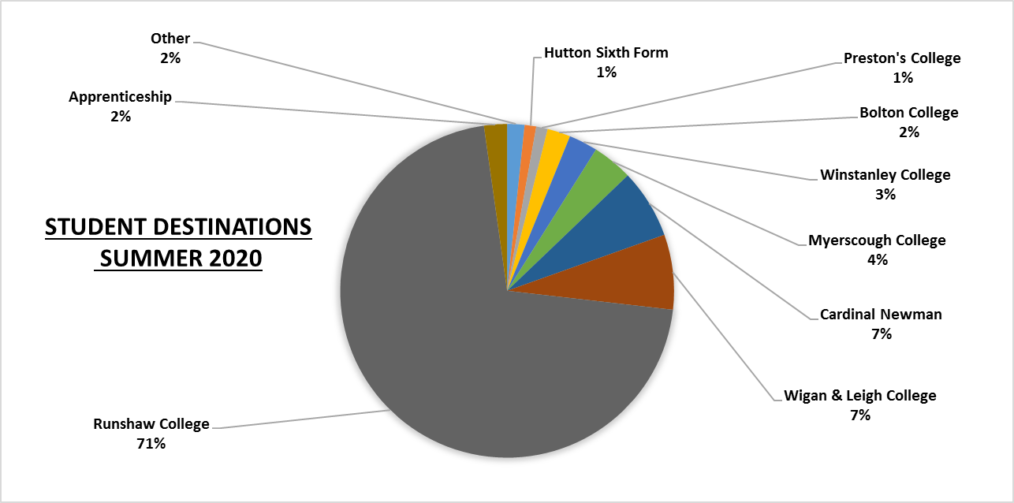
The Students classed as “Other” are:
1 student at West Lancashire College
1 Student at Southport College
1 student applied for the Royal Navy

A LEVEL VS VOCATIONAL
174 students have provided Bishop Rawstorne with definitive course information. 93 took A levels and 80 followed a vocational route.
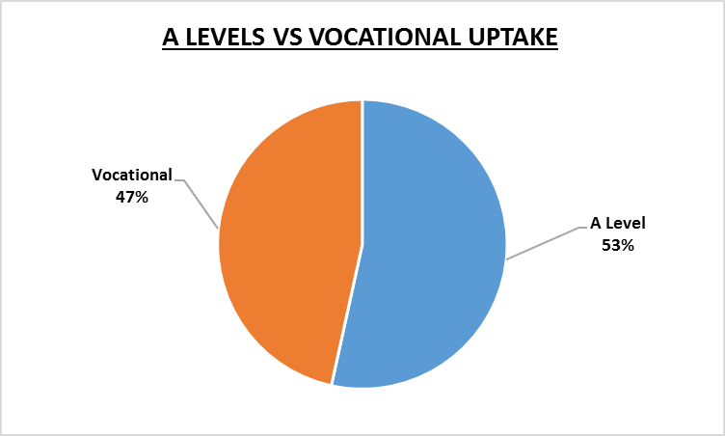
A Level Uptake
The table below breaks down the different subject areas that 93 students chose to take up at A level.
The 336 different A Level routes taken break down as follows.
Science is broken down separately, as are the TAC subjects and subjects with an uptake of 3 or fewer.
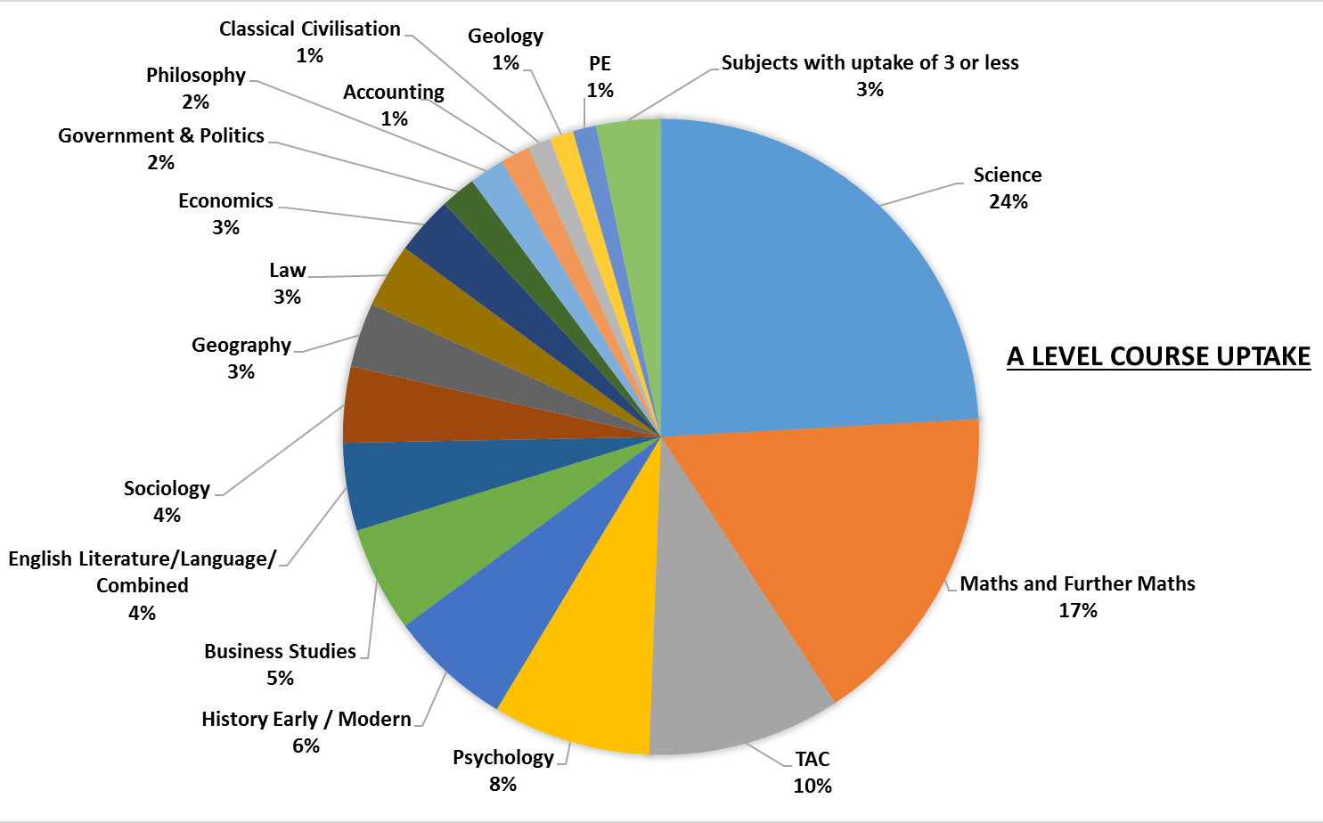
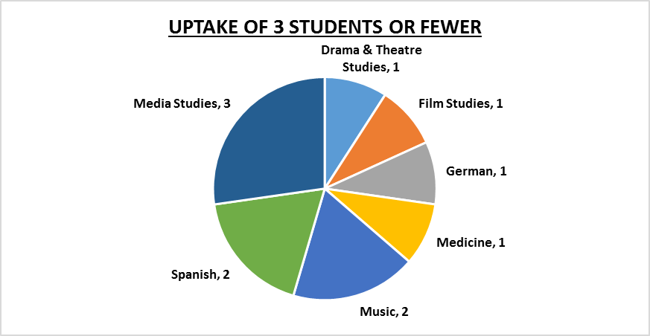
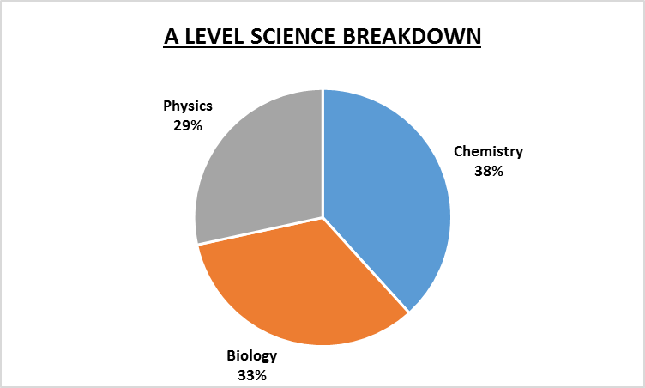
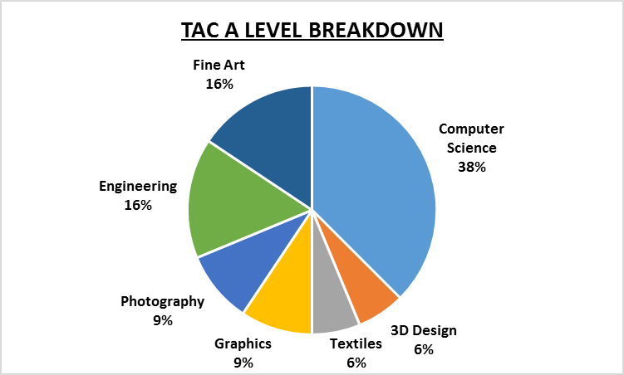

Vocational Uptake
The table below breaks down the different vocational areas that 80 students chose to follow.

