AQA Biology GCSE
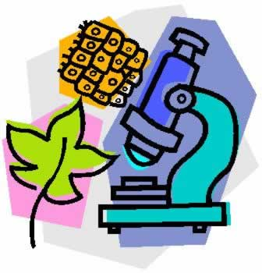
Specification code: 8461
Subject topics
- Cell Biology
- Organisation
- Infection and response
- Bioenergetics
- Homeostasis
- Inheritance, variation and evolution
- Ecology
Assessment
This qualification is linear. Linear means that you will sit all your exams at the end of the course.
For Biology GCSE you will have two exams. Each exam is 1 hour 45 minutes, consists of 100 marks and is worth 50% of your overall GCSE. Questions can be multiple choice, structured, closed short answer and open response.
Paper 1- topics 1-4 Paper 2 Topics 5-7.
As well as the subject content in each topic you will also be assessed on your experimental and mathematical skills.
Throughout your course you will carry out many investigations to develop practical skills and techniques with a variety of apparatus. However, there are ten core required practicals that you must carry out. You will be asked questions about these practicals in your exams.
Required practical activity | Title
- Microscopes | Use a light microscope to observe, draw and label a selection of plant and animal cells.
- Microbiology | Investigate the effect of antiseptics or antibiotics on bacterial growth using agar plates and measuring inhibition zones.
- Osmosis | Investigate the effects of a range of concentrations of salt or sugar solutions on the mass of plant tissue.
- Food tests | Use qualitative reagents to test for a range of carbohydrates, lipids and proteins.
- Enzymes | Investigate the effect of pH on the rate of reaction of amylase enzyme.
- Photosynthesis | Investigate the effect of light intensity on the rate of photosynthesis using an aquatic organism such as pondweed.
- Reaction times | Plan and carryout an investigation into the effect of a factor on human reaction time. .
- Plant growth | Investigate the effect of light or gravity on the growth of newly germinated seedlings.
- Field investigations | Measure the population size of a common species in a habitat
- Decay | Investigate the effect of temperature on the rate of decay of free milk by measuring pH change.

