Name ……………………………………….…. Group ………………………….
WHAT YOU NEED TO KNOW
AQA GCSE Chemistry – C6 - The rate and extent of a chemical change
Chemical reactions can occur at vastly different rates. Whilst the reactivity of chemicals is a significant factor in how fast chemical reactions proceed, there are many variables that can be manipulated in order to speed them up or slow them down. Chemical reactions may also be reversible and therefore the effect of different variables needs to be established in order to identify how to maximise the yield of desired product. Understanding energy changes that accompany chemical reactions is important for this process. In industry, chemists and chemical engineers determine the effect of different variables on reaction rate and yield of product. Whilst there may be compromises to be made, they carry out optimisation processes to ensure that enough product is produced within a sufficient time, and in an energy-efficient way.

6.1 Rate of reaction
Specification code | Expected knowledge and understanding | ☺😐☹
4.6.1.1  Calculating rates of reactions | a) The rate of a chemical reaction can be found by measuring the quantity of a reactant used or the quantity of product formed over time:  mean rate of reaction = quantity of reactant used  time taken  or  mean rate of reaction = quantity of product formed  time taken  b) The quantity of reactant or product can be measured by the mass in grams, by a volume in cm³ (or by an amount in moles.)  c) The units of rate of reaction may be given as g/s, cm³/s or mol/s.  d) HIGHER TIER - students are also required to use quantity of reactants in terms of moles and units for rate of reaction in mol/s.  Students should be able to:  - calculate the mean rate of a reaction from given information about the quantity of a reactant used or the quantity of a product formed and the time taken  - draw, and interpret, graphs showing the quantity of product formed or quantity of reactant used up against time  - draw tangents to the curves on these graphs and use the slope of the tangent as a measure of the rate of reaction  - (HT only) calculate the gradient of a tangent to the curve on these graphs as a measure of rate of reaction at a specific time.  - Recognise and use expressions in decimal form  - Use ratios, fractions and percentages  - Make estimates of the results of simple calculations  - Translate information between graphical and numeric form  - Draw and interpret appropriate graphs from data to determine rate of reaction
4.6.1.2  Factors which affect the rates of chemical reactions | a) Factors which affect the rates of chemical reactions include:  - the concentrations of reactants in solution  - the pressure of reacting gases  - the surface area of solid reactants  - the temperature  - the presence of catalysts.  Students should be able to:  - recall how changing these factors affects the rate of chemical reactions.  - Plot two variables from experimental or other data  - Determine the slope and intercept of a linear graph  - Draw and use the slope of a tangent to a curve as a measure of rate of change
Required Practical 5 | Investigate how changes in concentration affect the rates of reactions by a method involving measuring the volume of a gas produced and a method involving a change in colour or turbidity.  This should be an investigation involving developing a hypothesis.
4.6.1.3  Collision theory and activation energy | a) Collision theory explains how various factors affect rates of reactions. According to this theory, chemical reactions can occur only when reacting particles collide with each other and with sufficient energy. The minimum amount of energy that particles must have to react is called the activation energy.  b) Increasing the concentration of reactants in solution, the pressure of reacting gases, and the surface area of solid reactants increases the frequency of collisions and so increases the rate of reaction.  c) Increasing the temperature increases the frequency of collisions and makes the collisions more energetic, and so increases the rate of reaction.  d) Students should be able to :  - predict and explain using collision theory the effects of changing conditions of concentration, pressure and temperature on the rate of a reaction  - predict and explain the effects of changes in the size of pieces of a reacting solid in terms of surface area to volume ratio  - use simple ideas about proportionality when using collision theory to explain the effect of a factor on the rate of a reaction.
4.6.1.4  Catalysts | a) Catalysts change the rate of chemical reactions but are not used up during the reaction. Different reactions need different catalysts. Enzymes act as catalysts in biological systems.  b) Catalysts increase the rate of reaction by providing a different pathway for the reaction that has lower activation energy.  c) A reaction profile for a catalysed reaction can be drawn in the following form:  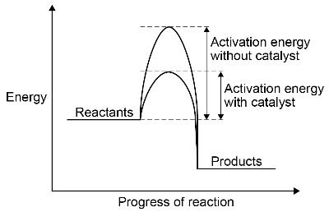  d) Students should be able to:  - identify catalysts in reactions from their effect on the rate of reaction and because they are not included in the chemical equation for the reaction.  - explain catalytic action in terms of activation energy.  Students do not need to know the names of catalysts other than those specified in the subject content.

6.2 Reversible reactions and dynamic equilibrium
Specification code | Expected knowledge and understanding | ☺😐☹
4.6.2.1  Reversible reactions | a) In some chemical reactions, the products of the reaction can react to produce the original reactants. Such reactions are called reversible reactions and are represented:  $A+B$ $C + D$  b) The direction of reversible reactions can be changed by changing the conditions.  For example:  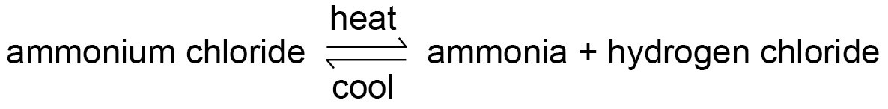  NH₄Cl NH₃ + HCl
4.6.2.2  Energy changes and reversible reactions | a) If a reversible reaction is exothermic in one direction, it is endothermic in the opposite direction. The same amount of energy is transferred in each case. For example:  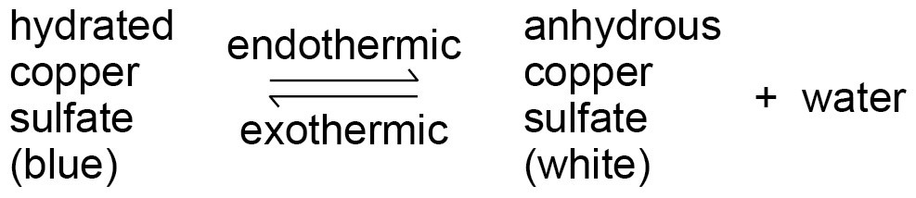
4.6.2.3  Equilibrium | a) When a reversible reaction occurs in apparatus which prevents the escape of reactants and products, equilibrium is reached when the forward and reverse reactions occur at exactly the same rate.
4.6.2.4  The effects of changing conditions on equilibrium  (HT only) | a) The relative amounts of all the reactants and products at equilibrium depend on the conditions of the reaction.  b) If a system is at equilibrium and a change is made to any of the conditions, then the system responds to counteract the change.  c) The effects of changing conditions on a system at equilibrium can be predicted using Le Chatelier’s Principle.  d) Students should be able to make qualitative predictions about the effect of changes on systems at equilibrium when given appropriate information.
4.6.2.5  The effect of changing concentration  (HT only) | a) If the concentration of one of the reactants or products is changed, the system is no longer at equilibrium and the concentrations of all the substances will change until equilibrium is reached again.  b) If the concentration of a reactant is increased, more products will be formed until equilibrium is reached again.  c) If the concentration of a product is decreased, more reactants will react until equilibrium is reached again.  d) Students should be able to interpret appropriate given data to predict the effect of a change in concentration of a reactant or product on given reactions at equilibrium.
4.6.2.6  The effect of temperature changes on equilibrium  (HT only) | a) If the temperature of a system at equilibrium is increased:  - the relative amount of products at equilibrium increases for an endothermic reaction  - the relative amount of products at equilibrium decreases for an exothermic reaction.  b) If the temperature of a system at equilibrium is decreased:  - the relative amount of products at equilibrium decreases for an endothermic reaction  - the relative amount of products at equilibrium increases for an exothermic reaction.  c) Students should be able to interpret appropriate given data to predict the effect of a change in temperature on given reactions at equilibrium.
4.6.2.7  The effect of pressure changes on equilibrium  (HT only) | a) For gaseous reactions at equilibrium:  - an increase in pressure causes the equilibrium position to shift towards the side with the smaller number of molecules as shown by the symbol equation for that reaction.  - a decrease in pressure causes the equilibrium position to shift towards the side with the larger number of molecules as shown by the symbol equation for that reaction.  b) Students should be able to interpret appropriate given data to predict the effect of pressure changes on given reactions at equilibrium.

