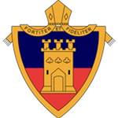
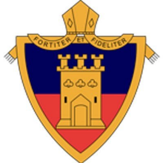
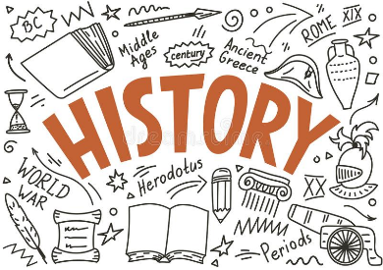
History Revision Guidance – 2022
A summary of your exams:
You will sit THREE examinations in the summer:
Paper 3 – Elizabethan England 1558-1603
Paper 2 – USA 1920-73
Paper 1 – Conflict & Tension 1918-39

Microsoft Teams
You will find all your revision materials on your class Team which your teacher has provided. This includes:
- Revision PowerPoints
- Class notes booklets
- Revision checklists
- Knowledge quizzes
Revision Workbooks
Your most important tool is your revision workbooks that you have completed in class. These give you a summary of the knowledge you will need for your exams, along with practice questions, checklists and knowledge tests.

You should aim to complete practice questions at home as part of your revision. Should you do this, hand in, email or send these via Teams to your History teacher who will mark your work and give feedback.

After school revision sessions
These sessions will run every Tuesday evening after February half term. The focus of these will be on both knowledge and exam technique to help prepare for your exams.

Kerboodle
You all have access to Kerboodle – here you will find lots of resources to help you with your revision. There are various quizzes, activities to support answering interpretation/source questions, as well as access to the revision guides and text books used by AQA.

History teachers
If you require any additional support please contact your History teacher via email or Teams – they will be more than willing to give you any support you need to help you prepare for your summer exams!

